How does Google’s mobile-friendly update affect my website and business?
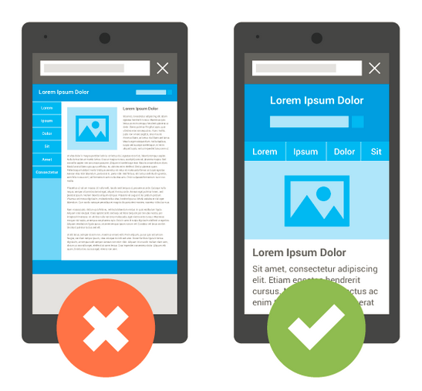
Here’s the gist: the Google update will boost the rankings of mobile-friendly pages (pages that are legible and usable on mobile devices) in Google mobile search results worldwide. The algorithm started rolling out on April 21st and was expected to take a few days to a week to take full effect completely and globally.
According to the Google mobile-friendly test, a page is either mobile-friendly or not, there are no degrees of mobile-friendliness. The mobile friendly algorithm checks sites page by page, so if only some pages on a site are mobile friendly those pages could benefit from this algorithm.
Using the mobile friendly testing tool will show if you pass the test, but Google may still need some time to update their index to pick up on the fact that your web pages are mobile friendly.
The update has no impact on desktop or tablet rankings.
How does this affect my website and business?
Ultimately, for sites that aren’t mobile friendly this could mean a decrease in mobile traffic. The driving force of the update is to provide helpful, relevant and functional search results for mobile users. It’s important to note that Google references over 200 factors in determining search rank, and high-quality content could rank well, even if it’s not mobile friendly.
At the end of the day, it’s important to give visitors a great experience overall. Almost every site can benefit from a properly functioning mobile experience to improve your traffic, click-through rate and sales.
Why Mobile and Why Now?
You’ve heard it before: more people are searching online using their smartphones and other mobile devices than ever before. In 2014, Internet usage on mobile officially exceeded PC, and last year mobile accounted for exactly half of Yahoo search traffic in North America.
If your business depends on being found through local search, such as a pedestrians Googling “coffee shop on Queen Street” from their phones, you could see a real impact on foot traffic if your site no longer shows up in mobile. Alternatively, with a mobile-friendly site you could be taking advantage of a boost in business.
If your site isn’t mobile-friendly, or you don’t want to continuously worry about the next big update Google might make that will affect your business, PARTNER has a simple online solution. With our Professional Design packages, a designer will build your business a website that’s mobile-friendly and professional design quality. Beyond improving your search results and having an impressive online presence, this is a great chance to outpace some of the competition.
Tests to determine if your site is mobile-friendly according to Google:
- Mobile-friendly sites will have a gray Mobile Friendly label in mobile search results, a feature Google launched in November 2014. Search for your business on a mobile device to check if your website has the mobile-friendly tag in the mobile search result.
- Google’s Mobile-Friendly Test: submit your domain and get a pass or fail. These test results will give helpful tips around how to improve your site to be mobile friendly. Screen shots shown might look a little different than it may on a phone to a real user. The reason for this is a site may be blocking resources (images, CSS or Javascript files for example) from Googlebot. If your site is blocking resources and the test is returning that your site is not mobile-friendly, try unlocking those resources.
- If you have a Webmaster Tools account, you can request a Mobile Usability report that outlines errors by page.

Some Frequently Asked Questions on the Google mobile-friendly update
What makes a web page mobile-friendly?
In general, a “mobile-friendly” web page is one which renders and functions well on small, mobile screens. According to Google, Googlebot checks the following criteria in assessing whether a web page is mobile-friendly:
- Does not include software that is not common on mobile devices, like Flash
- Uses text that can be easily read without having to zoom in or enlarge the screen
- Sizes content to the screen so users don’t have to scroll horizontally or zoom
- Places links far enough apart so that the correct one can be easily tapped
This may not be an exhaustive list, but ensuring your website achieves the above on mobiles means you’re providing a good user experience.
I believe my website is mobile-friendly, but it’s not passing the mobile-friendly test; why?
The most common reason is that Googlebot for smartphones is blocked from crawling resources, like CSS and JavaScript, that are critical for determining whether the page is legible and usable on a mobile device. To fix this, check if the mobile-friendly test results show blocked resources and make any required edits to allow Googlebot to crawl your pages properly.
Can I still update my website to be mobile-friendly and improve my search results?
Yes! Once your site becomes mobile-friendly, Google will automatically re-process your pages.
What can I do if my website is not mobile-friendly?
Mobile search is important, and is only going to keep growing and becoming a bigger source of your website traffic. You have a few choices: the first is to make the recommended fixes to your existing website returned from Google’s mobile-friendly test. This might be a few quick patches to your website, and it might be worth your while to consider investing in your overall user experience with a new website. A quick and affordable solution is to have a PARTNER Website Expert build you a new, responsive website for your business that covers all the bases.
How can I understand how much of my search traffic is mobile?
You can use Google Webmaster Tools to check your traffic sources. Select Search Traffic > Search Queries via the left-hand navigation, and from here, adjust the filters to show just “Mobile” search queries or just “Web” search queries. You can also take note of which keywords are driving traffic on mobile vs. desktop.
If I make my site mobile friendly today, how long will it take Google to pick up on those changes?
The algorithm is real time. Google has to crawl your web pages to determine if they are mobile friendly. Early tests show that it can take anywhere from a few hours to over 72-hours if you do everything right for Google to show your web pages as mobile friendly. Google states you can expedite the reprocessing by using Fetch as Google with Submit to Index and submitting your updated robots.txt to Google.
How will my non-mobile site be impacted?
It’s impossible to know how each site will be affected, because Google still takes over 200 factors into consideration when determining page rank. It’s been said that it will be more significant than both the Panda and Penguin updates, which could mean that more than 11% of the search results will change.
How does the update affect local and map results?
Google has said this update won’t impact the “local pack” results (see our Mobilegeddon FAQ for more), but Google’s local listings are hardly the only driver of traffic to local business websites.
Will this impact AdWords ads?
No, this is only for organic listings, AdWords may have their own mobile factors but this is unrelated. Search Engine Land recently reported having seen the “Mobile-Friendly” search tag showing up for AdWords Ads.

Resources
Google Webmasters Blog: http://googlewebmastercentral.blogspot.ca/2015/04/rolling-out-mobile-friendly-update.html
Google Webmasters FAQ: http://googlewebmastercentral.blogspot.ca/2015/04/faqs-april-21st-mobile-friendly.html
Google Webmasters Q&A session: https://www.youtube.com/watch?feature=player_embedded&v=v-0Q4s9ThU0
7 Common Mistakes on Mobile Websites from Google: https://developers.google.com/webmasters/mobile-sites/mobile-seo/common-mistakes/index
Search Engine Land FAQ: http://searchengineland.com/tomorrow-is-mobilegeddon-are-you-ready-for-the-google-mobile-friendly-update-219291

eMarketer, “How Much Yahoo Search Traffic Is Mobile?”. April 21, 2015.

